Sudan

## GNI per capita and development level

The data set shows the GNI per capita and development level of the country each year.

## # A tibble: 20 x 5  
## country iso3c date GNIperCapita devCategory   
## <chr> <chr> <dbl> <dbl> <chr>   
## 1 Sudan SDN 1996 843. Low Income   
## 2 Sudan SDN 1998 927. Low Income   
## 3 Sudan SDN 2000 945. Low Income   
## 4 Sudan SDN 2002 1022. Low Income   
## 5 Sudan SDN 2003 1063. Lower Middle Income  
## 6 Sudan SDN 2004 1065. Lower Middle Income  
## 7 Sudan SDN 2005 1117. Lower Middle Income  
## 8 Sudan SDN 2006 1115. Lower Middle Income  
## 9 Sudan SDN 2007 1266. Lower Middle Income  
## 10 Sudan SDN 2008 1285. Lower Middle Income  
## 11 Sudan SDN 2009 1332. Lower Middle Income  
## 12 Sudan SDN 2010 1307. Lower Middle Income  
## 13 Sudan SDN 2011 1497. Lower Middle Income  
## 14 Sudan SDN 2011 1497. Lower Middle Income  
## 15 Sudan SDN 2012 1686. Lower Middle Income  
## 16 Sudan SDN 2013 1701. Lower Middle Income  
## 17 Sudan SDN 2014 1760. Lower Middle Income  
## 18 Sudan SDN 2015 1802. Lower Middle Income  
## 19 Sudan SDN 2016 1841. Lower Middle Income  
## 20 Sudan SDN 2017 1841. Lower Middle Income

## GDP growth and economic growth classification

The data set shows the GDP growth and the ecomic growth classification of the country each year.

## # A tibble: 20 x 5  
## country iso3c date GDPannualGrowthRate GDPgrowthCategory4  
## <chr> <chr> <dbl> <dbl> <fct>   
## 1 Sudan SDN 1996 5.92 fast growth   
## 2 Sudan SDN 1998 4.31 moderate growth   
## 3 Sudan SDN 2000 6.35 fast growth   
## 4 Sudan SDN 2002 6.43 fast growth   
## 5 Sudan SDN 2003 7.73 fast growth   
## 6 Sudan SDN 2004 3.88 moderate growth   
## 7 Sudan SDN 2005 7.49 fast growth   
## 8 Sudan SDN 2006 10.1 fast growth   
## 9 Sudan SDN 2007 11.5 fast growth   
## 10 Sudan SDN 2008 7.80 fast growth   
## 11 Sudan SDN 2009 3.24 moderate growth   
## 12 Sudan SDN 2010 3.47 moderate growth   
## 13 Sudan SDN 2011 -1.97 negative grwoth   
## 14 Sudan SDN 2011 -1.97 negative grwoth   
## 15 Sudan SDN 2012 0.522 slow growth   
## 16 Sudan SDN 2013 4.39 moderate growth   
## 17 Sudan SDN 2014 2.68 moderate growth   
## 18 Sudan SDN 2015 4.91 moderate growth   
## 19 Sudan SDN 2016 4.70 moderate growth   
## 20 Sudan SDN 2017 0.768 slow growth

## Development trend

The plot shows the development trend of the country.

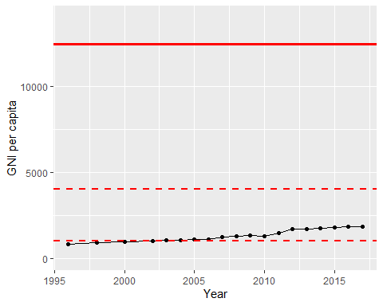

GNI Per Capita Trend